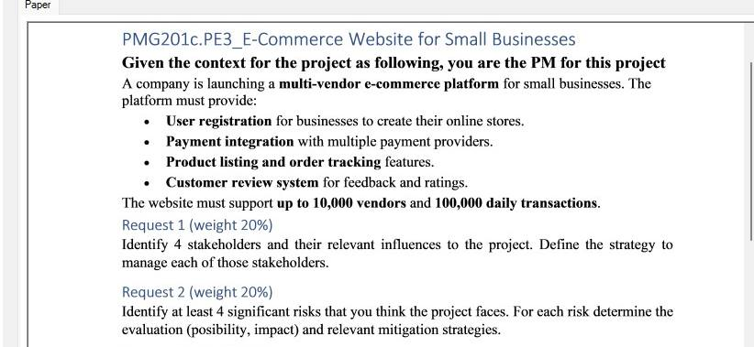
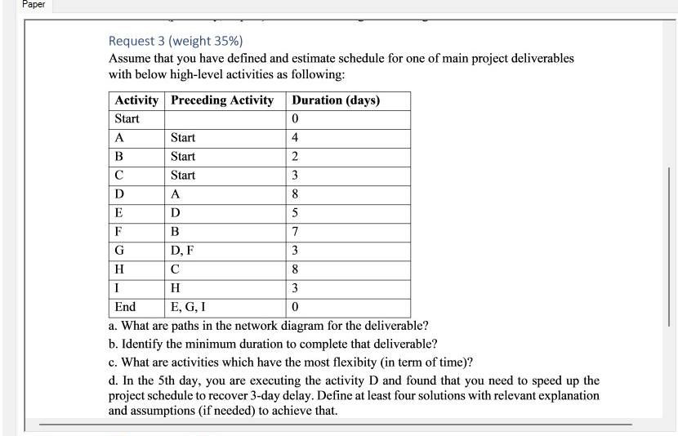
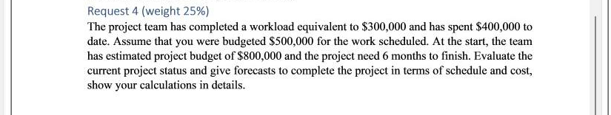

Request 1 (20%): Stakeholder Identification & Management Strategies
- Project Sponsor (Executive Sponsor / CEO)
  - Influence: High – controls budget, scope approvals, and strategic alignment.
  - Interest: High – wants platform launched on time and within budget to drive growth.
  - Management Strategy:
- Hold bi‑weekly steering committee meetings.
- Provide concise executive summaries with RAG status.
- Escalate major decisions promptly.
- Small‑Business Owners (End Users / Customers)
  - Influence: Medium – their adoption and feedback will determine platform success.
  - Interest: High – need an easy‑to‑use, cost‑effective store solution.
  - Management Strategy:
- Run focus groups and usability testing sessions.
- Maintain an open “customer advisory” Slack channel.
- Incorporate feedback via prioritized user stories.
- Payment Gateway Providers
  - Influence: Medium – control integration ease, uptime, and transaction fees.
  - Interest: Medium – want reliable integration and transactional volume.
  - Management Strategy:
- Establish clear API requirements and SLAs in a contract.
- Schedule regular technical checkpoints during integration.
- Maintain a “fallback” plan with a secondary provider.
- Development Team (In‑house Dev & External Contractors)
  - Influence: High – responsible for delivering features and quality.
  - Interest: High – I want clear requirements, a stable scope, and a manageable workload.
  - Management Strategy:
- Adopt Agile cadence: daily stand‑ups, sprint planning, retrospectives.
- Use a shared backlog with transparent prioritization.
- Provide timely answers to blockers via a dedicated Slack channel.

Request 2 (20%): Key Risks, Evaluation & Mitigation
Risk | Likelihood | Impact | Mitigation Strategy
1. Payment‑integration failure | Medium (40%) | High (9/10) | • Implement and test with two gateway providers (Primary + Backup)• Automate failover logic in checkout flow
2. Security breach/data leak | Low (20%) | Very High (10/10) | • Perform third‑party security audit and penetration tests• Enforce HTTPS, end‑to‑end encryption, WAF and regular patching
3. Scope creep | High (60%) | Medium (6/10) | • Strict change‑control board (CCB) reviews all scope changes• Prioritize via MoSCoW and adjust schedule/budget for new requests
4. Vendor onboarding delays | Medium (50%) | Medium‑High (7/10) | • Create a clear “Vendor Onboarding Kit” with checklists and sample data• Assign a dedicated vendor liaison coordinator• Use proactive reminders and escalation when deadlines slip

Request 3 (35%): Network Paths, Duration, Flexibility & Acceleration
a. All paths from Start → End
1. Start → A → D → E → End (4 + 8 + 5 = 17 days)
2. Start → A → D → G → End (4 + 8 + 3 = 15 days)
3. Start → B → F → G → End (2 + 7 + 3 = 12 days)
4. Start → C → H → I → End (3 + 8 + 3 = 14 days)
b. Minimum duration (Critical Path)
- The longest path is Start → A → D → E → End at 17 days.
c. Activities with the most total float (flexibility)
- B and F each have 5 days of total float (highest slack).
- Next: C, H, I each 3 days; G has 2 days.
d. Four schedule‑recovery solutions (recover 3‑day delay on Day 5 in D)
- Crashing Activity D
- Add two additional developers to D to finish in 6 days (instead of 8).
- Assumption: Resources will be onboarded immediately; marginal cost increase is acceptable.
- Fast‑tracking D → E Overlap
- Begin E work on the portions of D that are complete after Day 6.
- Assumption: E’s tasks are sufficiently independent of final D deliverables.
- Outsource Sub‐tasks of D
- Contract a specialist vendor for non‑core subcomponents of D, reducing D by 2 days.
- Assumption: vendor can mobilize within 2 days and maintain quality.
- Introduce Overtime & Double Shifts
- Run two shifts on D for the next 3 days, accelerating by ~1 day each.
- Assumption: the team is willing to work overtime; the overtime cost is budgeted.

Request 4 (25%): Đánh giá hiện trạng & dự báo chi phí
Áp dụng Earned Value Management cho tình huống:
- EV = $300,000
- PV = $500,000
- AC = $400,000
- Cost Variance (CV) = EV – AC = $300k – $400k = –$100k ⇒ dự án over budget.
- Schedule Variance (SV) = EV – PV = $300k – $500k = –$200k ⇒ dự án behind schedule.
- Cost Performance Index (CPI) = EV / AC = 0.75 (< 1) ⇒ hiệu suất chi phí kém.
- Schedule Performance Index (SPI) = EV / PV = 0.6 (< 1) ⇒ hiệu suất tiến độ kém.
Dự báo chi phí (EAC, ETC)
- Theo hiệu suất hiện tại:
  - EAC = BAC / CPI = $800k / 0.75 ≈ $1,066,667
  - ETC = EAC – AC ≈ $1,066,667 – $400,000 = $666,667
Dự báo tiến độ
- Dự án ban đầu cần 6 tháng; PV tương ứng 62.5% ⇒ đã trôi qua 0.625×6 = 3.75 tháng.
- Remaining Planned Duration = 6 – 3.75 = 2.25 tháng.
- Forecast Remaining Duration = 2.25 / SPI = 2.25 / 0.6 = 3.75 tháng.
- Tổng dự báo thời gian hoàn thành = 3.75 (đã qua) + 3.75 (còn lại) = 7.5 tháng.
Kết luận:
- Dự án dự kiến hoàn thành trong 7.5 tháng, trễ 1.5 tháng so với kế hoạch ban đầu.
- Tổng EAC ~$1.067 triệu, vượt so với BAC $800k.

